YoungPeople@Work
Reg. nr: 2012/210099/08 NPC

ANNUAL REPORT
Period: 1 December 2015 – 28 February 2017
(include 3 month extended report)

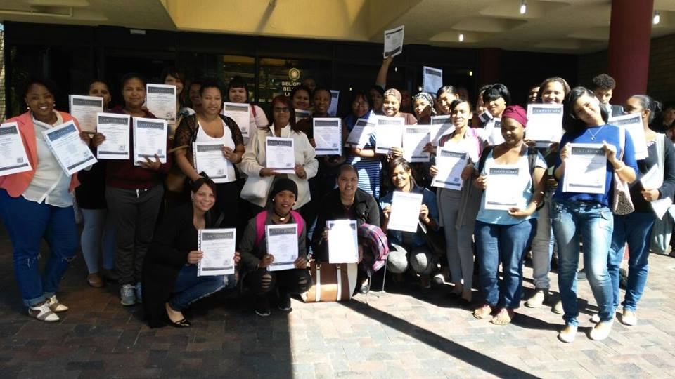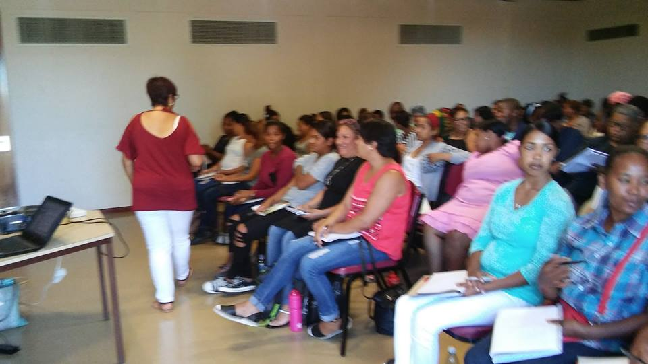

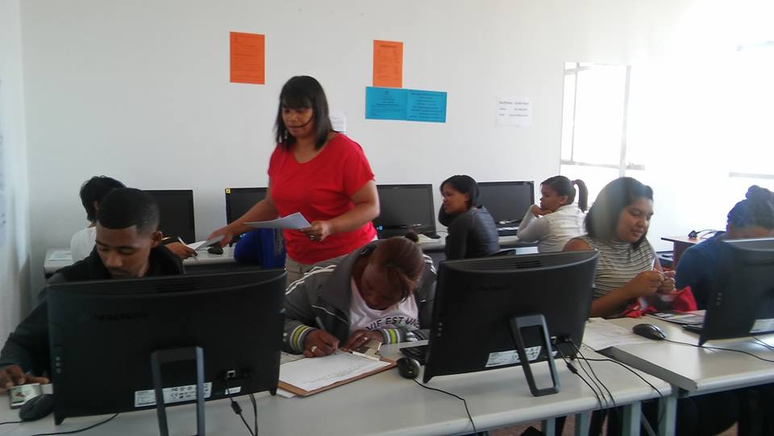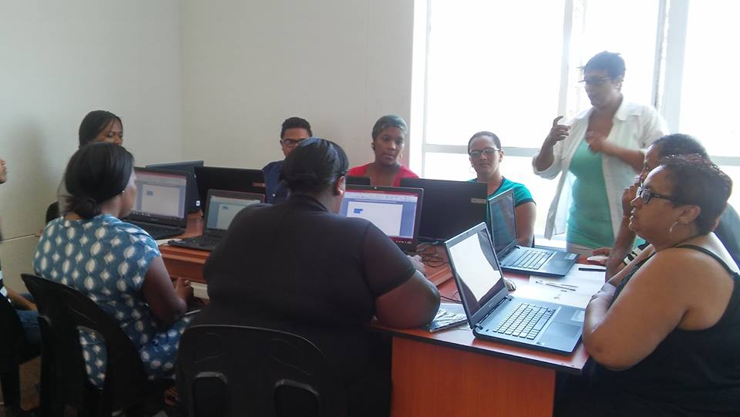

Prepared by: Frank Julie
Executive Director

Contact us here:
Cnr of Lavis Drive and Helderberg Road
Bishop Lavis
7490
Tel: 021 823 7837
Fax: 021 911 5444
Cell: 073 820 1534
Email: youngpeople.za@gmail.com
Website: www.youngpeopleatwork.weebly.com

Introduction:
This is the 4th annual report of YoungPeople@Work (YP@W) covering the period 1 December 2015 – 28 February 2017. This is an extended report since our board decided to change our annual audit period to 28 February (instead of 30 November) and will cover the following:

- The context
- Update on our projects
  - Community Information Sessions/Youth Empowerment Weeks
  - Online Job Search Training
  - Computer Training Academy
    - Community Investment Programme
  - Life Skills Workshops
  - Job Placement and Tracking
  - Rural Outreach
- Media and Marketing
- Networking
- Fund Development
- Finance
  - Summary of overall investment in training, savings and estimated income earned
- Office administration
- Board developments
- Other developments
  - Investment in other community organisations
  - Investment in staff/volunteer development
  - What some beneficiaries had to say
  - Risk factors
  - Strategic focus areas for 2016
  - Expression of gratitude

The context
The situation of unemployed youth in South Africa is getting worse! This is despite all government efforts to stem the tide of youth unemployment and despair. Our economy is currently bordering on recessionary conditions with almost zero economic growth. This is exacerbated by large scale government corruption, collusion by huge corporates, daily political revolts and uncertainty, collapse of public services such as education, etc. School leavers are the most vulnerable in this debilitating environment of hopelessness. Almost half a million children drop out of school before matric and educational experts are unanimous that the standard is deteriorating. School leavers are hopelessly unprepared for the world of work!
According to the labour force survey statistics released by Stats SA on a quarterly basis, unemployment is on the increase. Worst affected is the age group between the age 15-35 (the definition of youth in SA) at 62%. This is almost 3 times the rate of unemployment during the Great Depression of the 1920/30s when the highest level of unemployment was recorded at 24.9%! South Africa’s youth are therefore experiencing the effects of 3 Great Depressions every single day! Unable to make sense of this cruel world around them, our youth use escapism as a preferred method of intervention. About 25% of youth are now on drugs and reports suggest that teenage suicides are on the increase!
This is the context within which YP@W is operating. Unemployed youth who are the victims of the above scenario flock to our programmes as a means of empowering themselves in the hope of a better future. In the Western Cape province where we operate, the situation is economically slightly better, with some growth recorded, primarily due to the tourism and related service industries.

Update on projects:

Community Information Sessions/Youth Empowerment Weeks

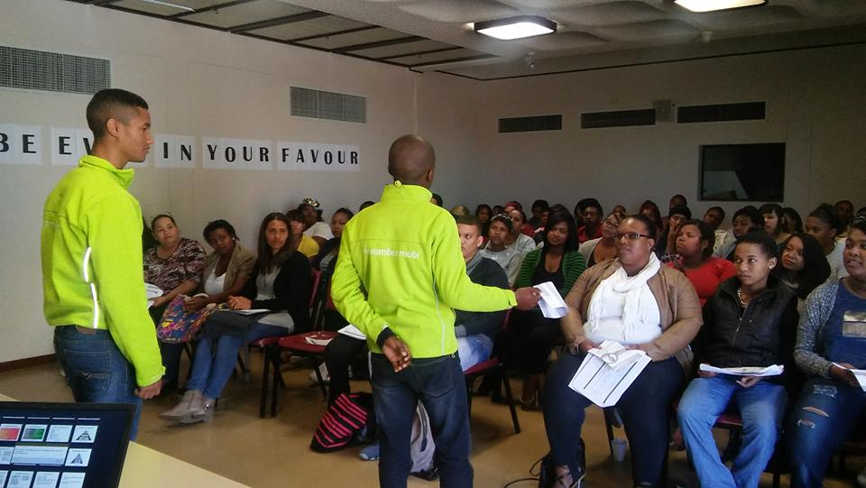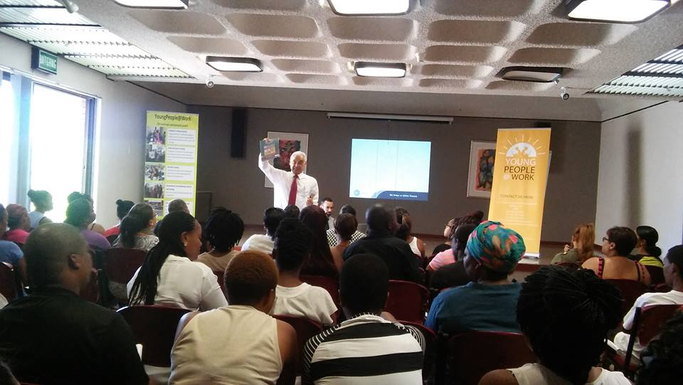

Reps from Harambee and Hoosain Adam from Holistic Financial Services at the Youth Emp Week

Successes:
Venue and area | Period | Nr of particpants
Bishop Lavis - CSD centre | 27-29 Jan 2016 | 54-56-37 = 147
Bishop Lavis – CSD Centre | 15-18 Feb 2016 | 69-86-84-116 = 355
Upper Room – Belhar | 23-24 Feb 2016 | 58 – 58 = 116
Bellville library | 11-12-13 April 2016 | 57-61-54 = 172
Grassroots – Athlone | 24-26 May 2016 | 96-82-72 = 250
Bellville library | 8 and 10 August 2016 | 86 – 65 = 151
Bellville library | 12-13-14 September 2016 | 74 – 78 – 83 = 235
Bellville library | 13-14-15-17-20 Feb 2017 (extended period) | 64-79-61-47-37= 288  Total: 1426  Extended period: 1714
Investment made:
Based on a market related fee of R350 per person per day for each workshop attended, our investment was:
1714 participants x R350 = R599 500
This programme has been highly successful in its implementation this year. Instead of the 5 youth empowerment weeks targeted, we managed to host 7, despite fewer staff members. We also managed to involve more partners to share information about placement opportunities, further training and referrals. More participants also registered for our paid computer classes or referred to our free online job search training. We plan to target more communities in the new year due to the demand for these workshops. The following partners participated in this programme this year:
Harambee Youth Employment Accelerator, National Youth Development Agency (NYDA), Department of Labour, RLabs, David Niemand IFA, Homemark, CSD Women’s Project, Houston Inititaives, Dreamworker and Homemark.
A serious challenge we face is the cancellation of participants on the day of the event or in many cases not just turning up without cancelling. This trend has been with us since our inception and we have overcome this by overbooking. Hence for every 10 participants registered we know at least 4 will cancel. In this way we ensure workshops remain full. Workshops are free of charge to allow for maximum attendance and not only those who can afford. Participants pay for their updated CVs and certificates.
Life skills training
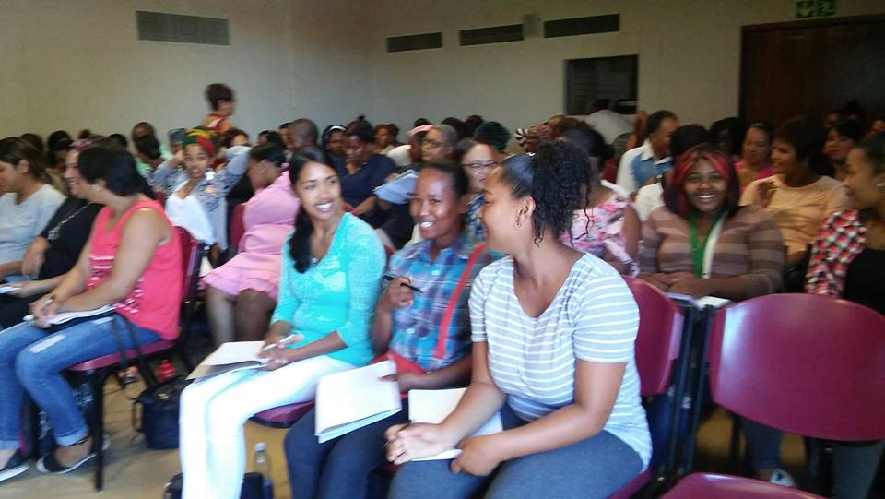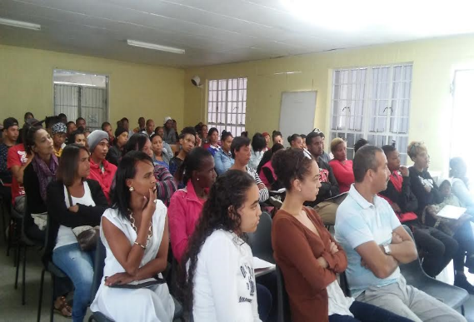
Participants attending life skills workshops in Bellvillle library and CSD centre in Bishop Lavis

Venue and area | Period | Nr of participants per day
Bishop Lavis - CSD centre | 29-30-31 March and 1 April 2016 | 98-76-42-55 = 269
Bishop Lavis – CSD Centre | 7-8-9-10 June 2016 | 46-49-52-36 = 183
Bellville library | 12-13-14-16 October 2016 | 41, 39, 36, 26 = 142  Grand total: 594 (500 in 2015)

Investment made:
Based on a market related fee of R350 per person per workshop attended our investment was:
594 x R350 = R207 900

We managed to achieve our target of 3 life skills courses as planned. The average number of participants attending was 40. These workshops were also used to assist with CVs, referrals for further training and completing matric and to our own online and computer training. We plan to integrate this life skills course with our Youth Empowerment Weeks to maximise attendance in future. We found that more participants prefer attending the basic office admin and bookkeeping skills workshops. This first experiment started in February 2017 and it worked. Our income from certificates and CVs also increased. More and more NPO members are beginning to attend these workshops since we started to market it to them. So far members from Ithemba Labantu, Salesians, Early Year Services and St.Johns attended. Discussions with Chrysalis Academy are in progress on this.

Basic call centre training
Our chairperson developed a basic call centre training course for unemployed youth who plan to seek employment in this industry. This was done in liaison with the director after the need was identified. The first group of 8 participants completed their training on 2-3 March. The second course was held on 8-9 March with 4 participants. A site visit was planned as part of the course but did not materialise. The training was very well received.

Community leadership training
Shareen Stonga, an ex-train the trainer participant, hosted a community leadership workshop over 4 days at the centre from 14-17 March. 24 participants signed up but only 10 attended. We are providing admin support for Shareen who is an ex-student on the TTT course. She paid an admin fee of R150 to cover our admin costs.

Recommendation
As mentioned, we are now going to integrate our youth week with life skills and host it in one week. First experiment started in Jan 2017 and it was highly successful. This will be varied with short 2/3 day youth weeks in various communities.

Online Job Search Training

This programme suffered some serious setbacks due to cable theft at the various libraries and the resignation of trainers. At the beginning of 2016 only Bishop Lavis library was affected. We then decided to use our own training room as a substitute. Later Adriaanse and Delft libraries were also affected. Lwandle followed later. Due to these developments the number of people trained dropped. Based on trainer feedback about slow participants the training sessions were also increased from 4 to 6 meaning fewer participants could be reached. This was reviewed again in September and changed back to 4 sessions. In response we opened a time slot at our Bellville training centre to also host online job search training.

With our relocation to Bellville and the freeing up of our laptops we made a drastic restructuring. We decided to use our own laptops (not dependent on cables) to host training at the various libraries. Where library computers were online we used them but as a back-up we are now using our own resources to host training. Bishop Lavis library was our first pilot and then Adriaanse library. Both were highly successful and even attracted more participants. We then rolled out to our Bellville training centre. Currently most training happens in Bellville since it is more accessible due to the taxi/bus and train routes. Since Facebook has become our primary medium of marketing, more and more youth is now requesting training using Facebook as means of communication. This makes it easier for us to organise sessions and host training in Bellville. We will still do outreach to libraries when our newly appointed trainer is properly trained. The strategy will therefore be to vary between the libraries and our Bellville training centre.

As planned, we are now sharing more information about our current courses and registering participants on our employment database. Referrals also happen during this training. The demand has increased to unmanageable proportions and we had to suspend registrations in February to manage a waiting list of over 200 people.

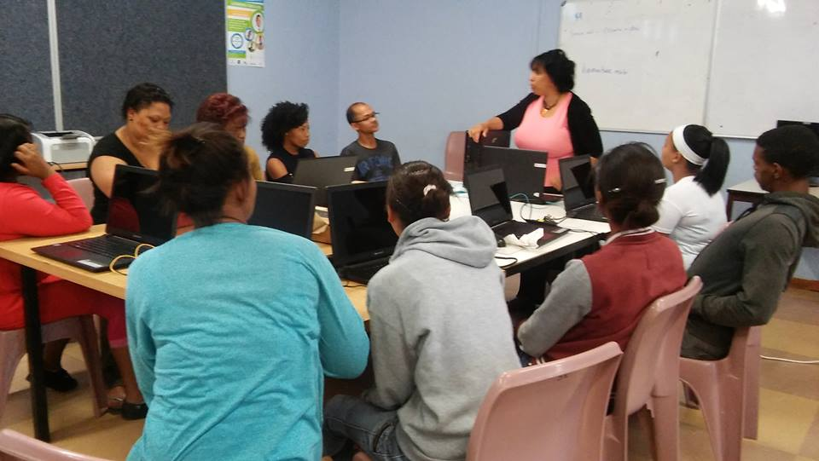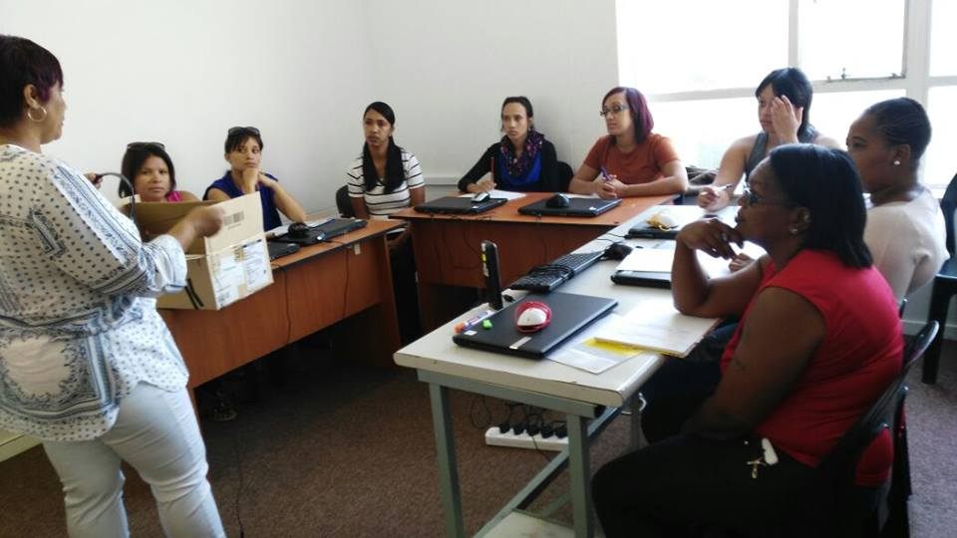
Bishop Lavis library Bellville training centre

Library / training site | Nr of participants (up to 25 Nov 2016)
Bishop Lavis training centre and library | 57
Adriaanse library | 13
Delft library | 18
Lwandle library | 26
Bellville training centre | 18  Total: 132

Training site | Nr of participants (from 16 Jan up to 28 Feb 2017)
Bellville training centre | 69
Total | 132 + 69 = 201 (227 – 2015 and 510 in 2014)

Investment made:
Based on a market related fee of R450 per person per course, the following investment was made:

R450 x 201 = 90 450

Computer Training Academy

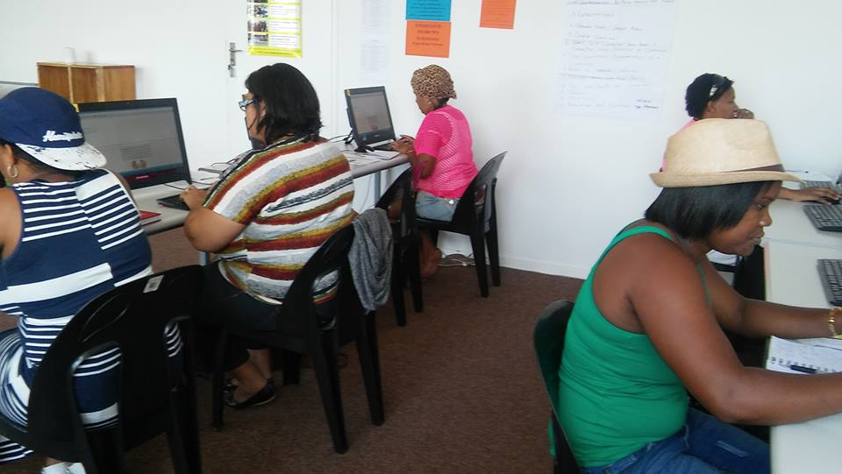

Bellville computer training room

Semester 1 | Nr of participants
Bishop Lavis | 18 | 37
Bellville | 19
Semester 2 | Nr of participants
Bishop Lavis | 18 | 35
Bellville | 17
Semester 3 | Nr of participants
Bishop Lavis | 32 | 55
Bellville | 23
Semester 4 | Nr of participants
Bellville | 29 | 29  Total: 156

Training site | Nr of participants (from 23 Jan up to 28 Feb 2017)
Bellville training centre | 41 + 156 = 197  151 trained in 2015 and 108 trained in 2014

Investment made:
Based on the average market related fee of R3500 and our subsidised fee of R1000, the following investment was made:
R2500 x 197 = R492 500

The relocation of the computer training centres had a disruptive effect on our work, especially in Bellville. Enrolments were very slow after September with the result that we had to provide a special discount on our normal fee. This had the desired effect and we managed to fill all our classes. Our relocation to Bellville meant we could not offer evening classes due to transport challenges. Saturday classes were therefore promoted in response to this. We are currently reviewing evening classes and looking at practical solutions.

We were only able to complete 4 semesters instead of the planned 5 due to the increased Youth Empowerment Weeks (7 instead of 3) attended by computer training participants. Extended course frameworks to accommodate slower participants were also a cause. This will be addressed urgently since fewer semesters mean less income generation and can affect our financial targets. One option is to emphasise our free practising sessions for slower participants instead of extending course frameworks. Except for mouse problems, no other serious hardware of software problems was experienced.

Community Investment Programme
This programme is aimed at organisations whose members are volunteering in their communities and lack the financial capacity to pay for computer training. This year we decided to charge a small admin fee of R250 to access the programme. We were flexible however in imposing this. There was a very slow response from organisations compared to last year. We have reviewed the admin fee and will only charge R150 in future,
The following organisations and individuals benefited from this programme this year:
Organisation | Nr of participants
St. Johns Ambulance Services | 9
Future Link (CSD Centre) | 8
Tygerberg Association for Street People (TASP) | 12 (two groups)  Total: 29

Investment made:
Based on market related fee of R1500 per person per course (over 8 sessions), the following investment was made:
R1500 x 29 = 43 500

Master Train the Trainer

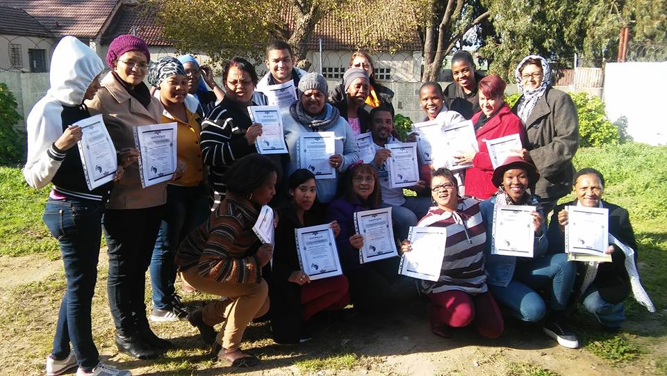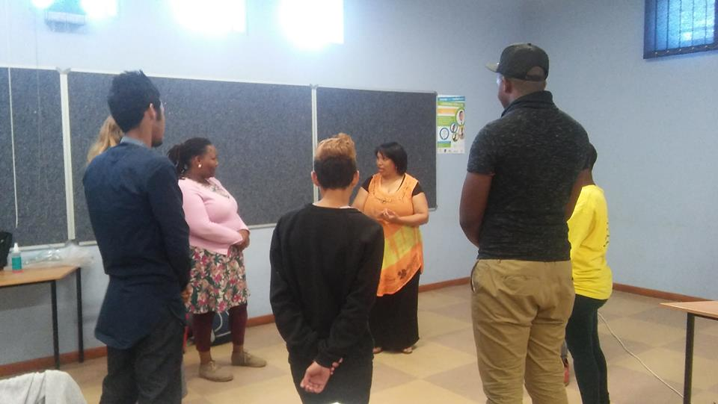
Master TTT hosted at CSD Centre and Bishop Lavis library

3 courses were hosted during this reporting period. This course has initially been facilitated for YP@W members to sharpen their training/facilitation skills. It was then opened up to outside people. Participants attending came mostly from ECD organisations and groups who benefited from our CIP programme. During this period participants from St. Johns Ambulance Service, Kolping SA, Shine, Ithemba Labantu, YP@W volunteers/staff, ex-participants and private individuals benefited.

Date | Nr of participants | Bursaries allocated
17-18-19 May 2016 | 11 | 0
27-28-30 June 2016 | 26 | 11
24-25-27 October 2016 | 8 | 4

Investment made (bursaries):
R700 x 15 = 10 500

Job Placement, tracking, referrals and job shadowing

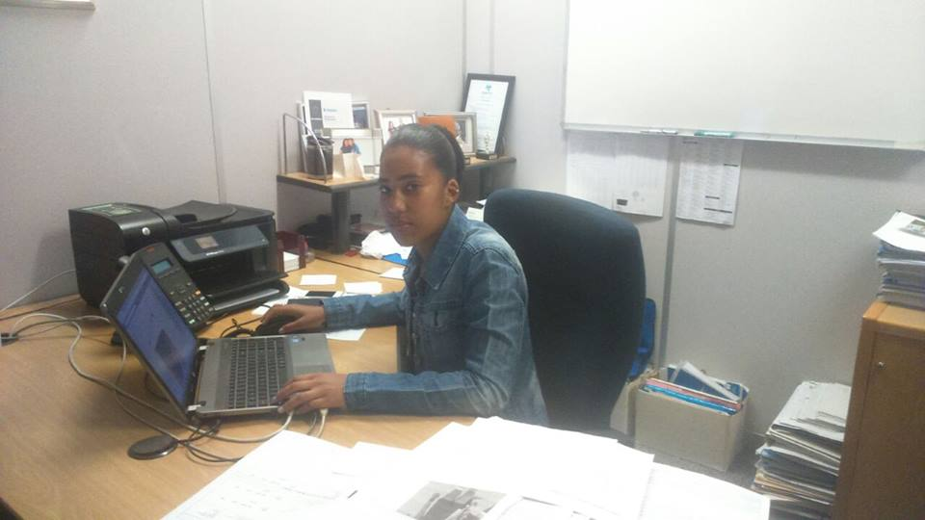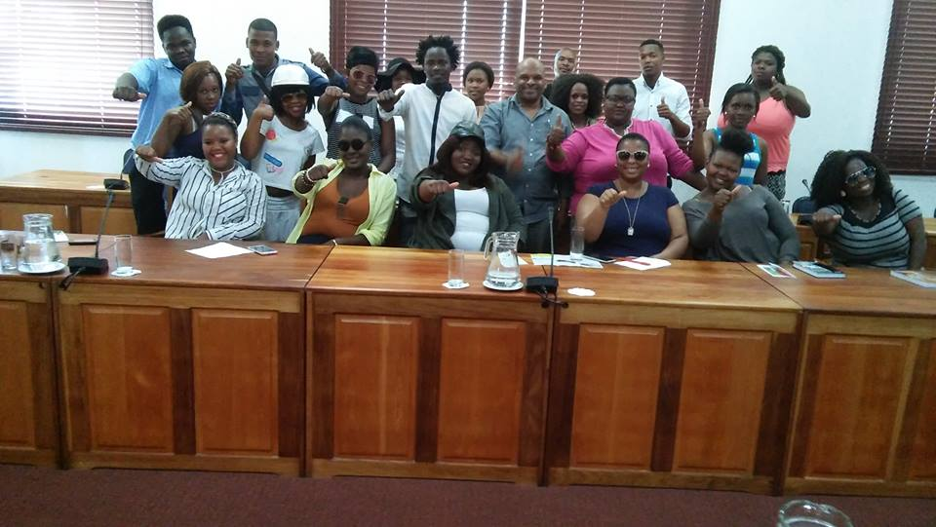
A participant placed at Sanlam Insurance and some unemployed youth placed in Plettenberg Bay

A summary of placements, referrals, job shadowing and income earned or savings made

Company/organisation | Nature of placements | Nr of placements
Mind Magic | 2nd phase hairdressing learnership | 14 x R1 500 pm stipend x 12 = R21 000 = R252 000 (2nd phase practical training) 3rd phase was put on hold
I-Can (Elsies River) | Multi-media training  Film production, computer training, mobile apps,  project and events management, Audio visual  social media  Course value at an average of between R1700 and R4500 per course | Could not access the figures from ICAN Centre
Surplus People’s Project | Job shadowing in office admin over 1 month @ 300 pm stipend (transport subsidy) = R600  1 year internship @ 2500 pm | 2 x 300 = 600  1 x 2500 pm x 12 =  30 000 (actual)
RLabs | Referrals to various social media course (participants referred do not confirm attendance and completion of courses. We have now decided to issue referral letters to keep track of participants referred. | Could not be verified
Harambee | Placement of unemployed youth at Woolworths in George, Plettenberg Bay and Mossel Bay: income generated over 2 months  Placements of YP@W workshop participants after Youth Empowerment and Life Skills Weeks (between Feb and November 2016) still awaiting update on the current period) | 156 @ 3600 pp x 2 months = 1 123 200 (actual)  (1st group) 50 screened of which 22 finally accepted.  (2nd group) 273 screened (2nd group) but only 66 finally accepted (no info on salaries earned)
Dreamworker | Job placements (1 participant at Jordan Shoes, 1 at CTP 6 month learnership, 2 at call centre learnership over 1 year. | 206 referred and only 4 placed @ an average R2000 pm x 4 x 12 = R96 000 (estimated)
Homemark | Referrals for store managers and regional managers | 9 CVs referred. Actual placements still in progress.
Gerli Clothing | Placement in clothing learnership (received a monthly stipend of R1100 per person) over 6 months | 12 x 1100 x 6 = 79 200
Fibre Patch | 9 candidates referred, 3 interviews | 1 permanent placement @ 6000 pm x 12 = 72 000
Bishop Lavis schools | Placement of teacher assistants; 12 referred but only one stayed on permanently (others left due to lack of payment and extra duties) | 1 placement at Bergville Primary
Call centre training | Hosted by chairperson of YP@W | 12 candidates completed
Matric referrals | Due to the overwhelming response over period of 4 weeks and the sharing of info on various Facebook pages it was difficult to determine the numbers reached. | Estimated 600 potential candidates provided with info. Not able to verify how many actually registered for matric classes
Other companies | Participants who completed various courses accessed jobs at the following companies: Sanlam Insurance, Foschini, Capitec, Ruushni Fashions, Vision Homes, | 5 (estimated income of R4000 pm earned x 5 x 12 = R240 000)
Total referred, placed and income earned |  | Referred and supported –  1 361  Estimated income earned – 1 892 400

Please note:
We have a tremendous challenge convincing participants on various courses to inform us when they access employment once they complete their training. Our placement and tracking results are therefore not reflective of the maximum number of placements. It only reflects information we have accessed based on our own tracking results, reports from partners and anecdotal evidence. In late January we started a partnership with Kolping SA (Netreg Branch) to refer participants for free bursaries in various fields for further study. This process of referrals is currently in progress and the first bunch of participants will be placed in April.
Job shadowing

Name and field | Organisation and shadower | Duration
Candice Julie for office admin | YP@W Clothilda Petersen | 1 month
Jodi Mesoni for office admin | YP@W Clothilda Petersen | 1 month
Ashleigh Mervin for org management | YP@W Frank Julie | 1 week
Jodi Mesani for office admin | YP@W Shirley De Jongh | 1 week
Lleyton Abrahams (Elsies River High School) for training | YP@W Lizel Kock | 1 week
Ashton Hendricks (Elsies River High School) for training | YP@W Lizel Kock | 1 week
Elvina Adams | YP@W Clothilda Petersen | 1 week
Observations
We were able to refer and place more participants this year. This relates especially to our partnership with Harambee. Through our networks we were able to go beyond the Cape Peninsula to facilitate placements in the Southern Cape in places like Plettenberg Bay, George and Mossel Bay. Delays were experienced with the phase 3 placement of the hairdressing participants and the implementation of the new learnership for 60 participants. Except for Harambee and Dreamworker, we are still experiencing challenges to track participants referred to RLabs Social Media Academy. To overcome this, we have now decided issue participants with referral letters as proof that they were referred by YP@W. RLabs has already been informed of this arrangement.

Challenges:
The placement of teacher assistants did not work well since no stipend was paid. The 3rd phase of the hairdressing learnership was also delayed. Although each staff member committed to host a minimum of 5 students for job shadowing, we were not able to achieve this objective due to disruptions at the centres, including the unplanned relocations.

Rural Outreach

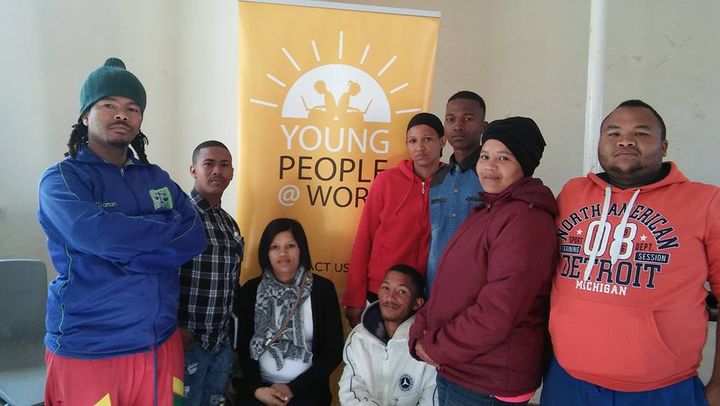

Participants from Graafwater and Nuwerus

Our projects director visited 5 rural areas as part of our rural outreach programme. Unemployed youth from Tsolo in Transkei, Mgwali village, Graafwater, Nuwerus and Nababeep were visited. The following activities happened:

Area | Activity
Tsolo | 4 day life skills week with 42 unemployed youth focusing on professional job seeking skills, personal development and leadership, money management and customer relations in partnership with Kwenzikele Youth Development Organisation. (Cost was covered by partner organisation)
Mgwali village | Information session with 48 unemployed youth (1 hour info session)
Graafwater | 2 hour Information session and tips on professional fundraising for 8 unemployed youth who members of the local Youth Bank in partnership with West Coast Community Foundation (Value: R2500)
Nuwerus | 2 hour Information session and tips on professional fundraising for 11 unemployed youth who members of the local Youth Bank in partnership with West Coast Community Foundation. (Value: R2500)
Nababeep | 2 hour Information session for 15 unemployed youth in partnership with the local municipality. (Value: R2500)
Total value invested: | R7500

Media and Marketing

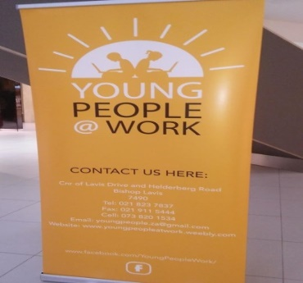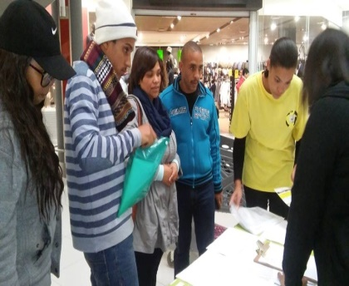

Our new logo captured on our shirts and banner and volunteers during an exhibition at Parow Mall

Marketing medium | Quantity and focus | Area covered
Pamphlets | No new pamphlets printed; existing pamphlets distributed | Mostly Bishop Lavis, Bellville, Parow
Posters | No new posters printed | Local NPOs, surgeries, YP@W training centre, local businesses in Bellville
Murals | No murals added this year
Radio interviews | 3 interviews focusing on programmes for unemployed youth (Radio 786)  Interview on Smile Radio  BBC World Service | Cape Peninsula  Cape Peninsula  International
Cape Town TV | 2 interviews on YP@W and our programmes with the director and 1 volunteer and ex-student respectively | National via DSTV
Banners | 2 new completed focusing on YP@W programmes | Displayed at workshops and Bishop Lavis library and Parow Centre exhibitions
Electronic newsletter | 3 editions focusing on youth issues, programme developments and YP@W success stories | 2000 subscribers nationally
Website | Continuous updating focusing on YP@W programmes | National and international
Facebook page | Daily updates on YP@W developments, success stories and job opportunities | 9862 followers – Feb 2016  (4482 followers – 2015) regionally, nationally and internationally
Newspapers | Tygerburger, Peoples Post and Athlone News – promoting youth weeks, computer and life skills workshops | 5 free articles and 4 paid adverts (in 2 editions) covering areas such as Bishop Lavis, Bonteheuwel, Delft, Belhar, Elsies River, Valhalla Park and Ravensmead with a circulation of 60 000 copies per newspaper
Block emails | Advertising our computer and life skills courses | Targeting mostly NPOs with youth volunteers
Whatsapp groups | Advertising our computer and life skills courses and advanced training; also started sharing with many other pages hence the phenomenal increase in our followers in 2016 | Targeting participants, ex-participants, walk-ins and youth empowerment week participants
Block sms’s | This mode of marketing has been suspended due to the costs involved and due to the opening of whatsapp groups | Suspended
Word of mouth | Advertising our computer and life skills courses and job opportunities | Continuous and our main marketing medium based on participant surveys in workshops and application forms
Exhibition | 1 exhibition sharing info about YP@W programmes; partner programmes and registering participants for our courses; completing CVs | Parow Centre (Mall) targeting unemployed youth from the northern suburbs
Brochures | 2500 copies printed | Distributed at YP@W workshops
Profile document | Reflective doc detailing the background and methodology of YP@W | Distributed to various stakeholders

According to a survey conducted amongst our participants, the most popular mediums to find out about YP@W are:

Facebook , Newspaper (articles and adverts), Word of mouth, Pamphlets, Murals, Radio, Others

Our most recent assessment determined that Facebook is becoming the most popular medium through which participants accessed info about YP@W programmes, followed by newspapers and word of mouth. Our objective has been to increase our Facebook following to save money on newspaper adverts. Through various techniques we have doubled our Facebook following since last year, achieving this objective.

Networking
Our current network partners are:

Partner | Investment made
RLabs Social Media Academy and Youth Café | Free scholarships for social media training
Harambee Youth Employment Accelerator | Referrals for jobs at mostly retail companies
Department of Labour | Information about services and free labour advice
Dreamworker | Referrals for jobs
National Youth Development Agency | Information about youth services and funding for youth cooperatives
Western Cape Youth Development Forum | Networking and exposure of our programmes in the bi-weekly newsletter
Tygerberg Association for Street People | Free training and office space (until May 2016)
I-Can technology centre | Free bursaries for IT and social media raining
Virtuous Women Pampering Group | Free pampering sessions for female participants at selected workshops
Surplus People’s Project | Internships
Community libraries | Free access to computers and WIFI for online job search training
Bellville library | Hosting of 4 Youth Empowerment Weeks and one life skills course
Belhar library | Hosting of 1 Youth Empowerment Week
Bishop Lavis library | Hosting of 2 Master Train the Trainer workshop and online job search training
Delft, Adriaanse and Lwandle libraries | Hosting the free online job search training
Youth Lab | Access to research info about unemployed youth and networking with other national stakeholders
Kolping SA | Access to free bursaries for further training in office admin, catering (chef), home based care, ECD, hospitality, plumbing

Fund Development
The following is a summary of funding received and proposal submitted:

Donor | Amount requested | Status
Kerk in Acktie | R340 000 | R320 000 received
Firetech |  | R6500 and 5300 donated (unsolicited)
SPZA |  | R6940 (balance of previous tranche)
Total amount |  | R338 740 (R149 692 - 2015)
Funding applied for
TK Foundation (Bahamas) | R800 000 (2 years) | Declined
National Lotteries Commission | R495 000 | We have been advised to enquire every month about the status of our application (After more than a year we decided not to pursue this source any longer)
HCI Foundation | R100 000 | Declined
Community Chest – WC | R100 000 | Awaiting a response
Rockerfeller Foundation | R800 000 | Declined
Magi Fund | R200 000 | Declined

Despite all our efforts to expand our external funding base, we were not able to access new funds. This is a serious concern since our cost base has increased when we moved to our new Bellville offices. Trainers are also paid slightly more as part of a retention strategy. With only one single major donor, we are extremely vulnerable financially. This issue will be addressed with urgency in 2017. One constraint is the director who acts in a part-time capacity due to other responsibilities and the quality time needed to address this is a weakness.

Own income generation

Income streams | Amount
Computer training fees, USB sales, computer manuals, rummage sales | R125 946 (R145 958 – 2015)
Workshop fees, manuals, CV typing, printing | R16 214 (R13 738 – 2015)
Individual donations (Facebook appeals) | R37 290 (R18 827 – 2015)
Volunteer and board contributions (for daily tea and coffees) | R1780 ( R1200 – 2015)
Interest from notice account | R4099.17
Subtotal | 185 329.17 (up to 30 Nov 2016)  (179 723 in 2015) (90 000 in 2014)  (36 249 in 2013)
Material donations and estimated value
Material donations from workshop participants | Suspended due to increased fees for CVs and certificates
Material donations from partners (Rainbow House, St Mary’s Home, RAM | Donations of clothes and other hardware towards our volunteer Khutazwa whose shack burnt down @ estimated R3000
TASP – free rent in Bellville | 2000 p.m. x 5 = 10 000 (up to May 2016)
J&B Associates and Accounting (auditors) | 12 000 (discount on audit report)  3 free basic bookkeeping workshops x 3000 = 9000
Hoosain Adam (Holistic Financial Services) | 1 free money management workshop x 3000 = 3000
Saving on staff salaries (Salary and stipends in including transport subsidies averaged R20 000 pm x 12 = R240 000 p.a.) @ 50% of market related salaries | Saving made = R20 000 x 12 =  R240 000
Subtotal | R262 000
Own income for the extended period (1 Dec 2016-28 Feb 2017) | R8400+R12 081.63+R10 675 = R31 156.63  + 185 329.17 = 216 485.80 + R262 000
Total amount | R478 485.80

Summary of investment through discounted and free training and savings made:
Investment made through free training: R1 451 850
Savings made: R262 000
Amount participants earned (actual and estimated) = R1 892 400
Total estimated investment through training, savings and income earned = R3 606 250

Observations:
The reduction in computer fees was a result of the reduced semesters from 5 to 4 as well as the 30% discount that was offered with the final course. Evening classes were also cancelled due to evening transport challenges for facilitators as mentioned. The closure of the Bishop Lavis training centre also caused a loss of income. Fewer donations were received from workshop participants. We decided to increase the fee for certificates and apply it to all courses. Fees for members from NPOs were also increased since this has been identified as an important income stream. We hope that our plan to combine life skills workshops with the Youth Empowerment Weeks will generate more income since we plan to attract more participants. Our individual base of giving, especially via Facebook, has also doubled and we were fortunate to upgrade two repeat donors (from London and Dubai) to permanent debit orders of R1500 p.m. and R1000 p.m. respectively. This means that we are secured of a R30 000 donation per annum from these two donors. During our recent Facebook campaigns, we were also able to recruit a number of first time donors. We also plan to levy an admin fee for companies when referrals and placements are made. Participants securing employment will also be required to pay R250 once off as a placement fee.

Finance
Bookkeeping has been outsourced to HGG NPO Financial Sustainability. The system is in the final stages of being completely set up. This will save us money to employ a fulltime bookkeeper and ease the accounting work of our auditor.

To maximise interest on our accounts we opened a 32 day notice account with FNB which was later shifted to Investec due to a higher interest rate being offered as well as a one day notice period instead of 32 with FNB.

Our collection of computer fees is still very efficient with the trainers playing an important role in the process. Since last year we were able to record a 95% collection rate. This is a huge improvement to the 75-80% of two years ago. A new fee structure for services was introduced this year based on our assessment last year in December. Fees for certificates, CVs and NPO members attending life skills workshops were increased. Computer fees were increased for employed people. Participants attending free online job search training were also requested to pay for certificates and CVs. These new arrangements had a significant impact on our income generation in January and mid-February 2017.

Office administration

Our move to our new offices in Bellville allowed us a more professional approach and image to our office administration. Extra space became available in October 2016 allowing us to separate computer training from office admin. A new wifi system was installed by Neotel, solving our internet connection problems. With each trainer and admin having access to their own laptops, admin is now more streamlined. Information is properly captured and filed physically and electronically. This enabled our monitoring and evaluation to be more effective.

Board developments
The board met 3 times this year. Victoria Petersen joined the board during this period. She joined us as a volunteer in August 2012 and was trained as a computer facilitator. She subsequently was employed by Dreamworker as a placement officer.

Staff/volunteer development

Staff members and volunteers were exposed to the following training:

Activity | Facilitator
Professional fundraising workshop | Frank Julie
Effective money management | Frank Julie
Effective mentoring and coaching | Frank Julie
The value of informal learning in adult education | Prof Dan Moshenberg (USA)
Intermediate and Advanced MS Word and Excel (still in progress) | Shirley De Jongh
Mentoring of Mandilahke Songelwa | Shirley De Jongh
Job shadowing (admin) for Khuthazwa Gadlela | Clothilda Petersen
Mentoring for online training – Khuthazwa Gadlela | Doreen Cussendala
Mentoring for online training – Vuyokazi | Doreen Cussendala
Master Train the Trainer for Doreen Cussendala and Khuthazwa Gadlela | Frank Julie
Google for non-profits for Shirley De Jongh | Sangonet (hosted by ICAN Centre)
Counselling skills and practical for Lizel Kock | CSD Centre

Staff responsibilities and changes

Frank Julie – Projects director (March 2012) | Org management, external fundraising, training of trainers, marketing, board development, staff evaluations, networking, transport, banking, shopping, financial planning, reporting, strategic planning, life skills facilitation, rural outreach
Shirley De Jongh (Aug 2012) | Bookkeeping, job placements and tracking, online and 6 week computer course facilitation, office admin facilitation, admin and workshop bookings, online and computer class bookings, minute secretary for board meetings, workshop coordination and logistics
Lizelle Kock (Jan 2014) | Online and 6 week computer course facilitation, assistant job placement and tracking, workshop assistant
Linda Williams (appointed 1 Feb 2017) | Online computer facilitator, workshop assistant, customer relations facilitator (in progress)
Mandilakhe Songelwa (Aug 2014) | Online computer facilitator – resigned
Doreen Cussendala (Feb 2014) | Online computer facilitator – resigned
Clothilda Petersen (June 2014) | Office administrator, computer facilitator – resigned
Khuthazwa Gadlela (Jan 2016) | Online computer facilitator – resigned

Other developments

What some beneficiaries had to say

Luzinda Petersen wrote: Thank you YP@W for this great opportunity you've helped me a lot!!!! Our facilitator Liesl was the best! Liesl, you never, under any circumstance, made me feel inadequate, you are one hell of a tutor and a one in a million human being! I'm forever grateful to you guys!!!
Boniwe Ndukwana wrote: Thank you YoungPeople@Work for this life changing opportunity you have given me. It is a head start to greater ventures. Please continue with the wonderful work you doing. It was great learning about computers, thanks for teaching me about CV attachments and the Do's & Dont's of computers. Thank you very much Shirley you explain everything so well.
Anita Adams wrote: "Good day Frank and team! It is Anita I just want to thank you for all the wonderful information you have shared with us. I went for an interview yesterday and it was successful. The little pocket guide you gave us was very useful and the tips on how to make an excellent CV. The interviewers loved my CV and they were impressed with my answers they even said they wouldn't want to lose me! II will start training on Monday and have also taken the opportunity to volunteer at Tygerberg hospital. You have really motivated me and I now know I can do anything I put my mind to it feels very good now knowing what I want to be in future and what my goals are."
Nekeitha Anderson wrote: “I wish I heard of YP@W sooner as I could have been equipped with these skills sooner. I didnt know what to expect in the training but I was impressed with their patience and passion in what they do. I have learnt so much in this 4 days and is excited to use what I have learnt in my everyday life. The instructors take a personal interest in each trainee individually and is eager with helping us further our careers and to obtain employment. I like to thank everyone who is involved with this iniative as you really do change lives!”

Risk factors
- Funding (we need to further expand our external funding base)
- Staff retention (we need to further consolidate our current staff base and ensure they are well paid to retain them)
- Part-time director (proper remuneration is required to ensure a stronger focus on YP@W management) Currently fulltime work results have to be delivered on a part-time basis.

Strategic focus areas for 2016
- Expand the external funding base and further deepen our own income base.
- Employ two more part-time staff members to alleviate pressure on existing staff
- Consolidate our marketing strategy in relation to social media to further cut down on paid adverts.
- Increase the level of placements and referrals by developing more partnerships to maximise impact.
- Improve documentation of placements and referrals through our partners (referral letters).

Conclusion and expression of gratitude
This was a very tumultuous year for YP@W! We lost half of our staff and we also closed the Bishop Lavis office and training centre and centralised all our work in Bellville. Prior to this our Bellville training centre at TASP also closed and we had to find alternative training space. Coupled with external factors beyond our control, like the cable theft at various libraries, it was a miracle for us to have produced the results recorded in this report. Our current staff rallied to the call to do more with less. Tasks were reallocated and new plans formulated to continue serving our unemployed youth.

I wish to thank all those who played a role in carrying the organisation through this difficult period. A big thanks also to our donors, big and small, who generously contributed towards our financial sustainability, allowing us access to the resources to achieve our mandate!

We thank you

Frank Julie
Executive Director
20 April 2017

